**Watermark Improvement**

In original paper, they propose watermark embed method based on H264 encode motion vector direction.

In here, they have fixed block position which embedded watermark. and when embed N watermark, they select N frames subsequently.

But this method have only consider intra mode only when mismatch predicted motion vector direction with watermark value, but not consider motion vector length.

In general in watermark research field, it is also important to keep robust in attacking.

In other words, other use cannot distinguish watermark embedded effect easily, and robust for attempting erase watermark information.

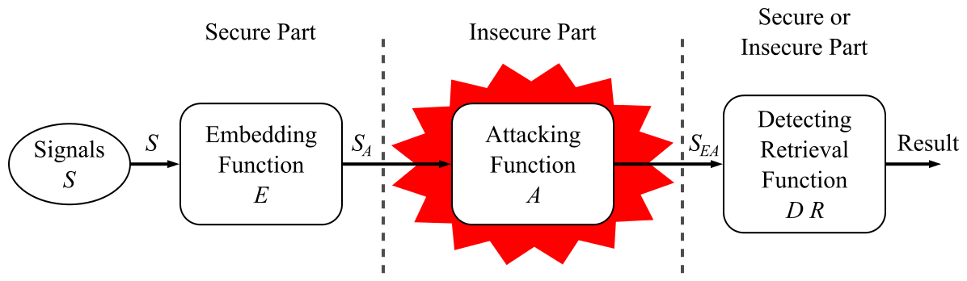

The bigger motion vector region watermark is embedded, the more robust watermark information is, because other attacker cannot distinguish embedded watermark information in big motion region easily.

So my algorithm is as follow.

Step 1. In each frame, select a micro-block which has the biggest motion vector.

Step 2: Assign motion vector length to each frame with the selected biggest micro-block's motion vector length.

Step 3. Sort total video frames by motion vector length.

Step 3. select first N biggest frames, and corresponding biggest motion micro-block for selected each frames.

Step 4: for each selected frames and blocks, apply watermark method in original paper.